**Auto-scaling tasks**

1. **Create one vpc in N.virginia region.**

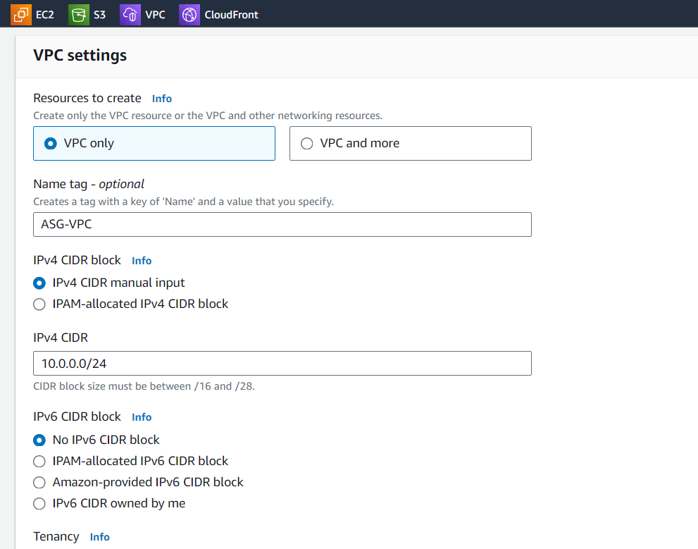

**2) Create two subnets.**

**One Public subnet and one private subnet.**

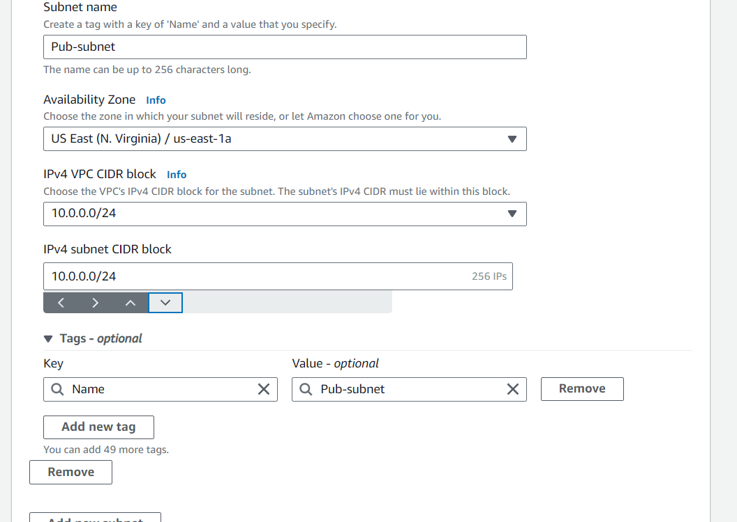



1. **Provide the IGW to the vpc.**

1. **Create One public RT and one private RT.**

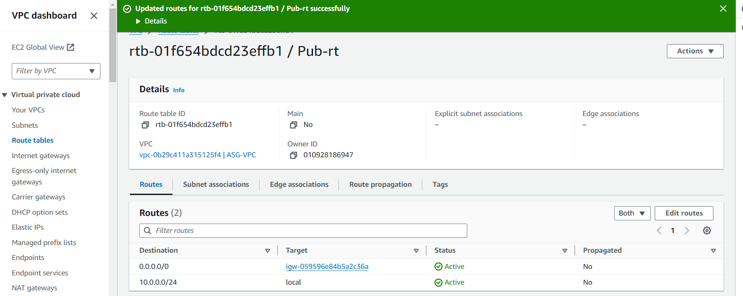

1. **Deploy NAT gateway on public subnet and attach the NAT gatewat to private subnet.**

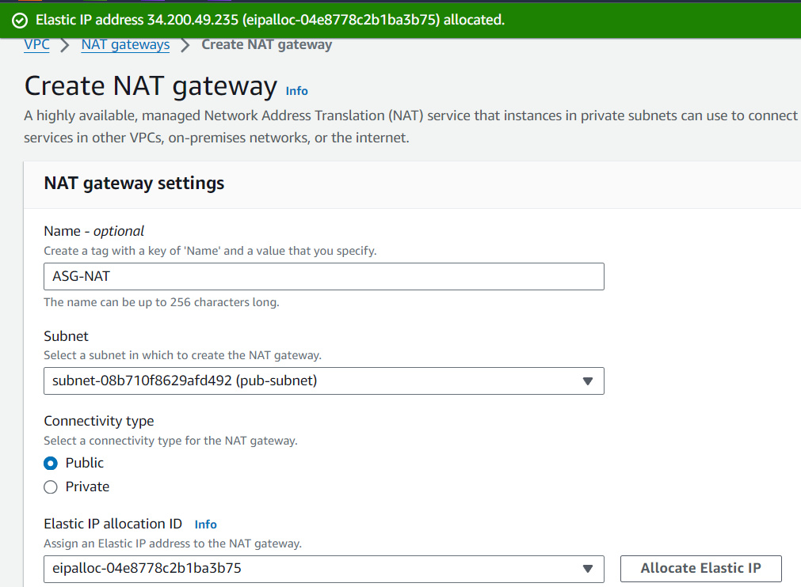

1. **Create Two instances,one in public subnet and one in private subnet.**

**Creating a instance in public subnet**

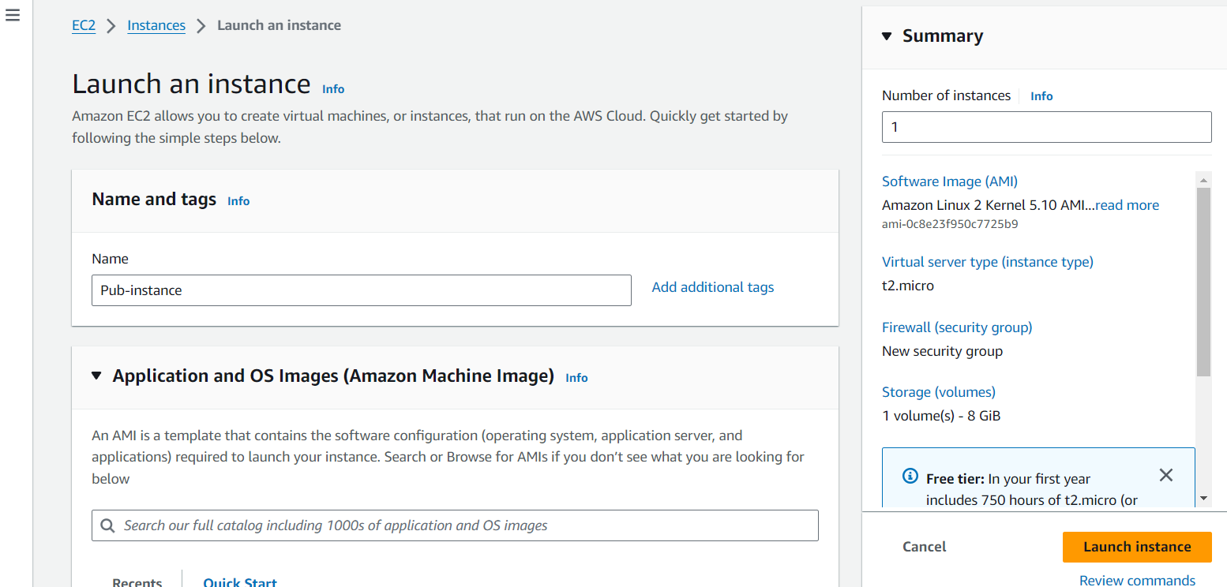

**Create a instance in pvt subnet**

1. **Deploy Apache server on both the ec2 instances with sample index.html file.**

**Create a html file**

**Now connect with pvt instance via jump server by generating ssh keygen.**

**Copy the pemkey and create a new file and paste the pemkey. And then connect with new pemkey with pvt address**

1. **Create one application load balancer and attach the load balancer to both the ec2 instances.**

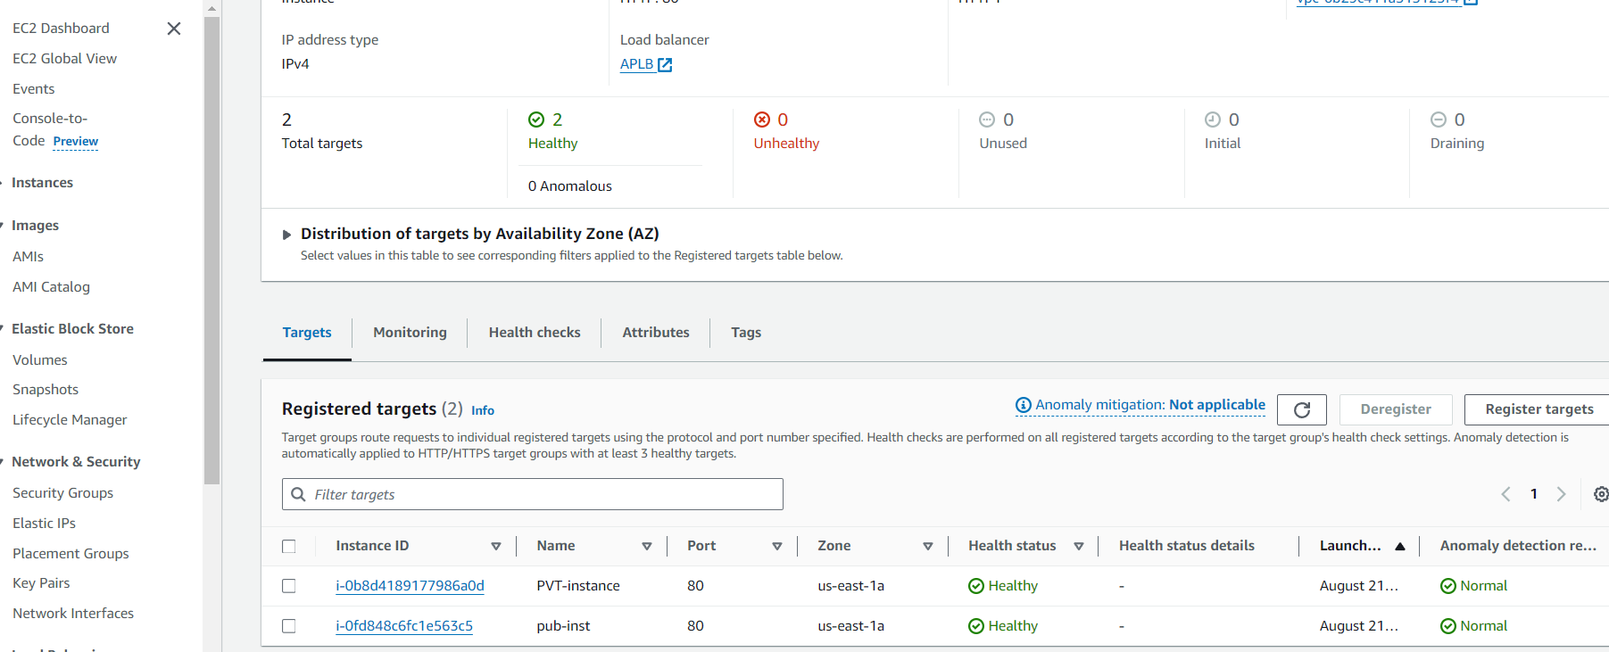

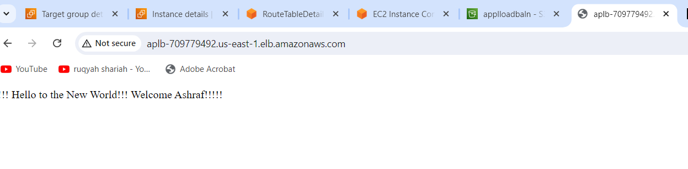

1. **Store Application load balancer logs to s3.**

1. **Store the vpc flow logs to cloudwtach group.**

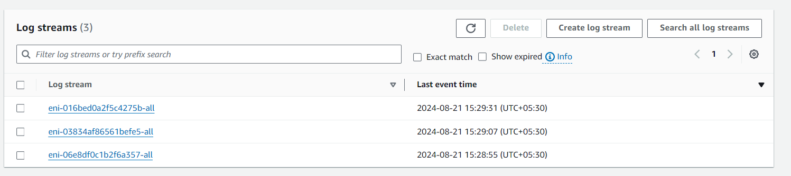

1. **Create Monitoring Dashboards to monitor cpu utilization and to monitor apache service.**

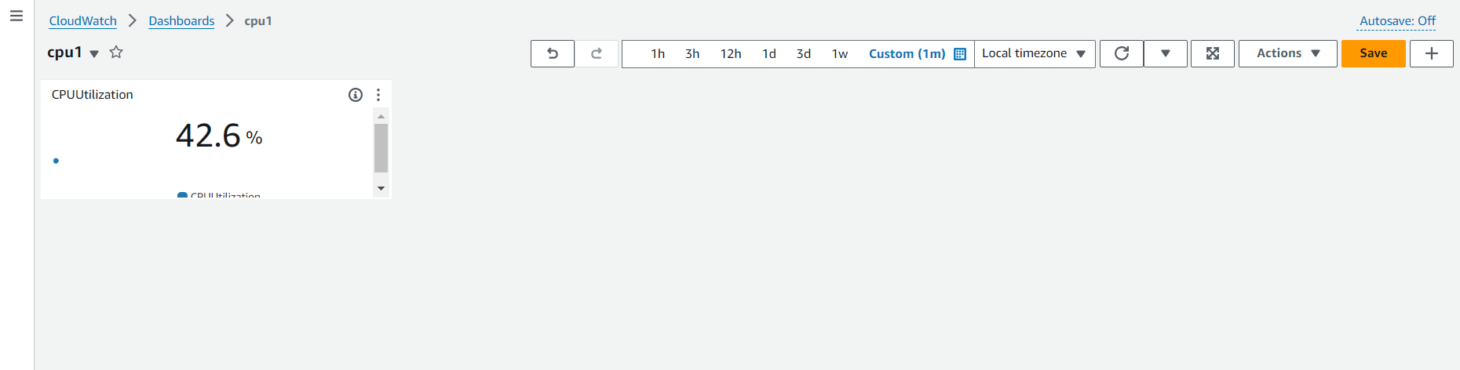

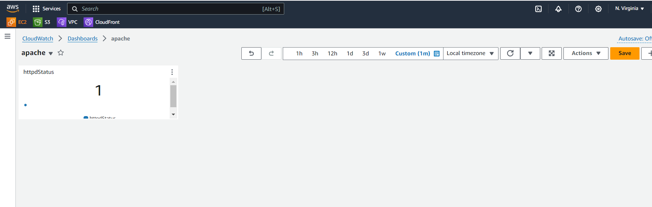

1. **CPU utilizationis more than 70% then it should triggere Autoscaling and launch new instance.**

